This document is a simple release note for DVW-624i new FW of ORION assurance testing. And it describes how to update new FW to the device.

FW File:
DVW-624X_11.00.12_20250919_174716_r7985.img
MD5SUM_FW_9b0ec9557a314812bf3ab0722bbfc28f

[How to upgrade to new FW]
Please access the WEB GUI by https://192.168.1.1:88 through LAN1 port and login with admin/faction.
Please upload the FW to DVW-624i through WEB GUI, System MGMT -> Image Upgrade -> Upgrade in local as below
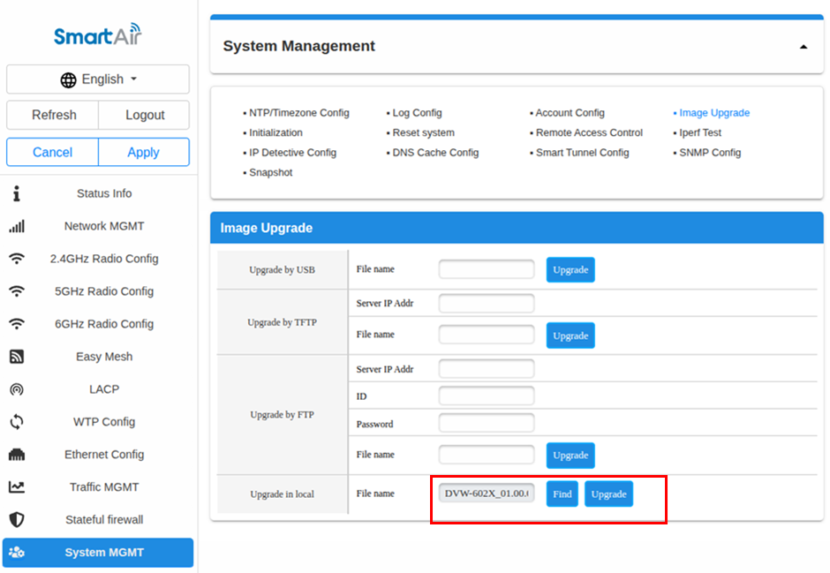

[Login password]
Following is the password’s rule.
PW = “DVW-624 + # + The last 10 digits of the serial number + !”
For example,
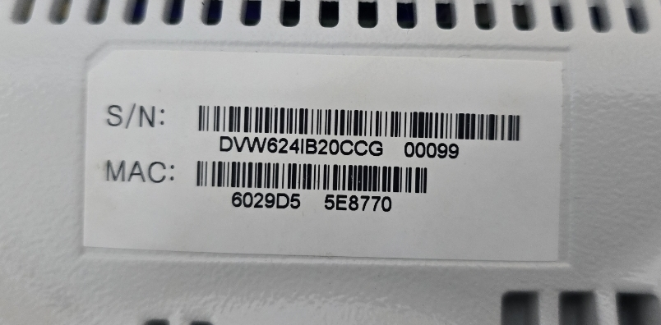
If SN is DVW624iB20CCG00099, PW is DVW-624#20CCG00099!

[Verify upgrading new FW]
Please access the WEB GUI by https://192.168.1.1:88 through LAN1 port and login with admin/faction.
Please Check FW version, Status Info -> System Info as below
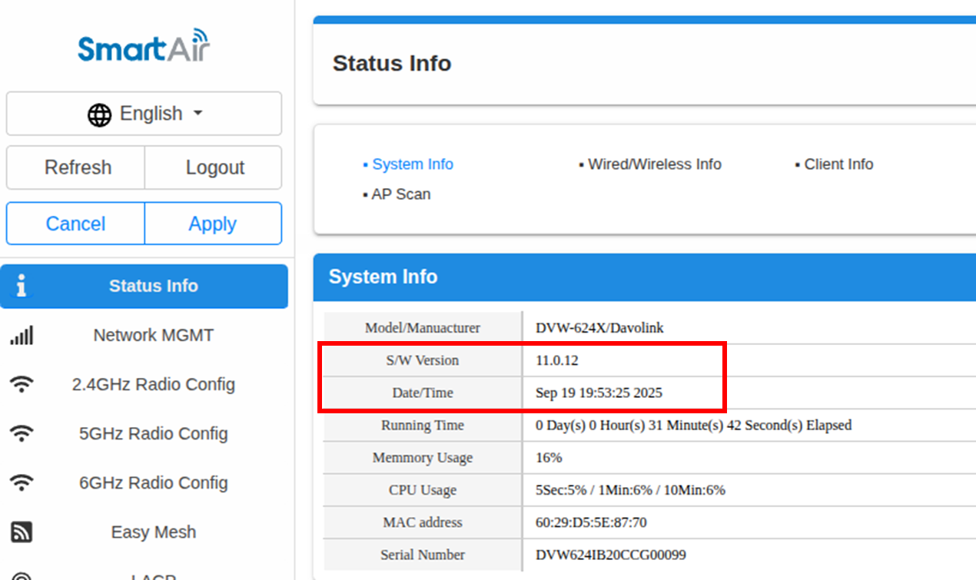

Followings are the remediations against FAIL cases of ORION test.

- Security for the web server has been enhanced. It’s the remediations of “1.2 EXTERNAL ATTACK SURFACE > HTTP Form Fuzzer” of ORION retest.

We have found a bug at the WEB server SW of DVW-624i. Processing HTTP/HTTPS POST messages from clients could result in crashes due to memory handling errors. This issue has been resolved in this FW.

- HTTP service is removed. It’s the remediations of “1.1 COMMUNICATIONS > Secure Communications”

